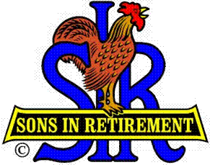
Las Trampas Branch 116
BEC Meeting Agenda
June 17, 2019, 9:30 AM
The Mission of SIR is to improve the lives of our members through fun activities and events – while making friends for life.

09:15 Coffee Available
09:30 Call to order; Secretary confirm a quorum
09:31 Secretary – Fred Schafer – Approval of April 15 minutes
09:33 Treasurer – Jim Nickels – Report, Missed Luncheon Receipts, Dues
09:37 Standing Reports
- Attendance – Jim Flessner – Attendance, Guests and Visitors
- Membership – Phil Goff – New Members to be inducted,
- Spring Fling wrap-up – Marty Katz for Alan Fitzgerald
- Nominating Committee Slate – Marty Katz
09:48 Department Head Reports
1. Activities – Fred Wachowicz
09:56 Big SIR Report – Jerry Hicks
1. State Convention August 19 and 20 at Thunder Valley Resort Casino
2. Branch Officer Training, October 11, Rossmoor
3. Outside catering; form 63 and 64; pending lawsuit in State
4. Area Social for BEC’s and spouses – Tony de Losada
10:02 Little SIR Report – Michael Barrington
1. Speaker: Susan Wood, Photo Journalist
10:06 Old Business
- Reminder: E-payments with Venmo are now working
10:10 New Business:
- Membership Video – “What can You do?” http://www.sirinc.org/MemInfo/DwindlingMembership.html
- Discussion on Membership and Recruiting
10:22 Other Discussion
10:25 Adjourn; Next BEC Meeting, July 15, 0930

